Install laravel in ubuntu
Follow this document ( https://www.techiediaries.com/install-laravel-8-php-7-3-composer/ )
laravel documentation link ( https://linuxize.com/post/how-to-install-laravel-on-ubuntu-18-04/ )

1 – install apache2 to check the version (apache2 -v)
2 – instlal php 7.3 or above to check the version (php -v)
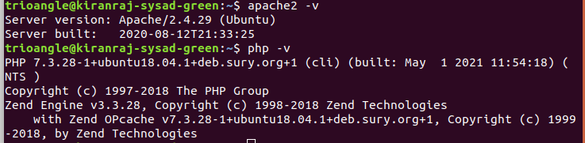

2 install composer and check the version (composer -v)
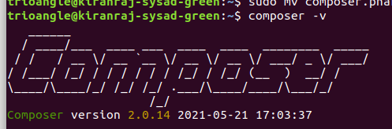

3 install php modules for 7.3 from here ( https://computingforgeeks.com/how-to-install-php-7-3-on-ubuntu-18-04-ubuntu-16-04-debian/ )
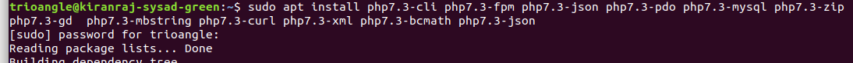
4 – install laravel ( composer create-project --prefer-dist laravel/laravel my_app )
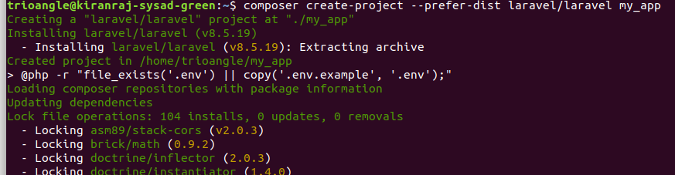

laravel installed sucessfully
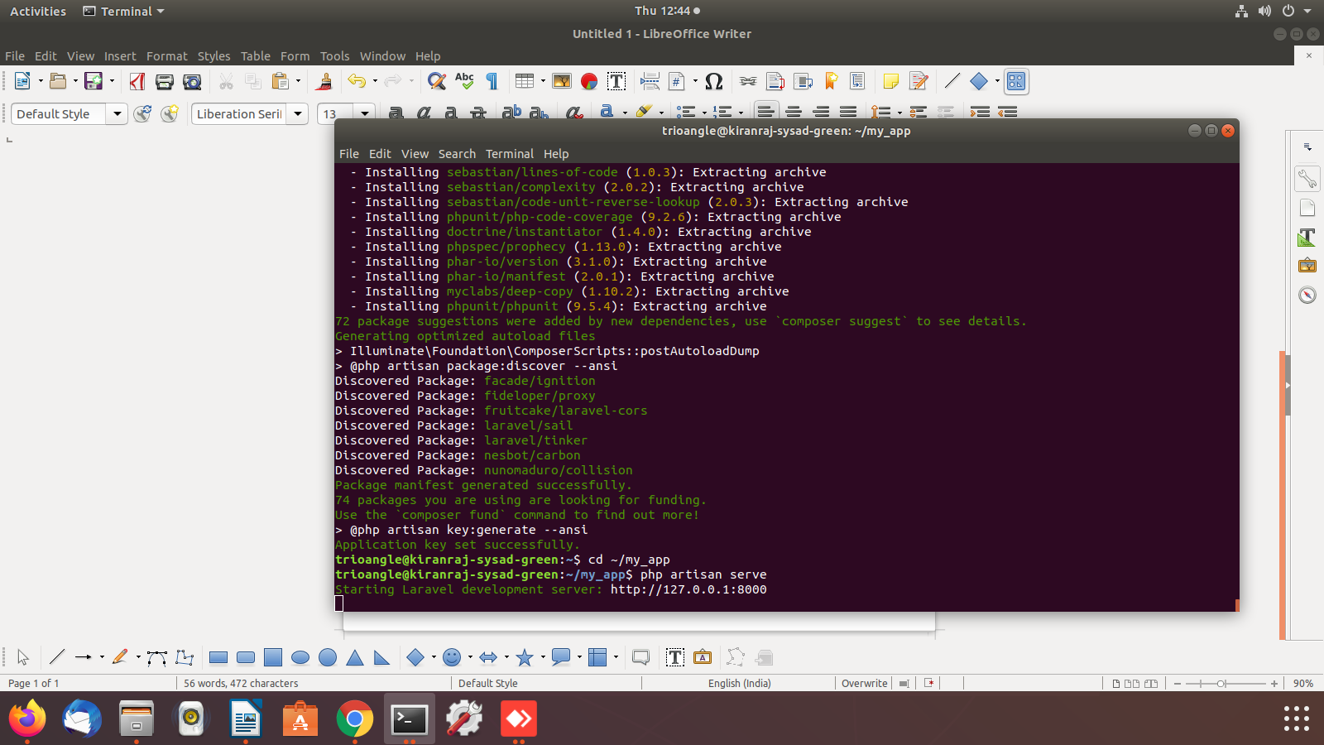

5 – now move in to the “cd ~/my_app” and execute this cmd “php artisan serve”

6 - To verify open browser and type http://127.0.0.1:8000 and assume the installation is successfull

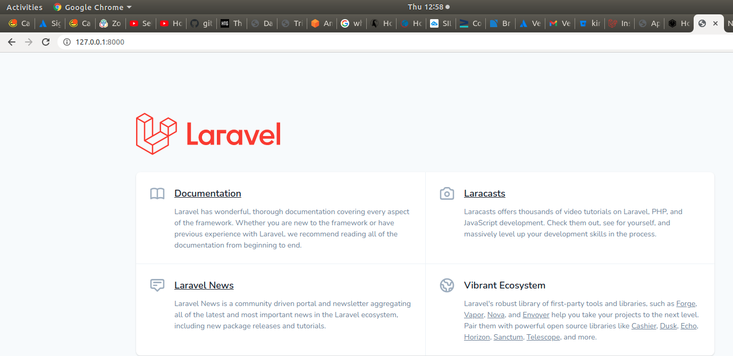
7 - right vhost in etc/apache2/sites-available/000-default.conf

